Emma Waryjasz
November 22, 2011
Period F
Type 3
FCA 1: Organization is clear: introduction, topic development, and concluding statement (4 points)
FCA 2: Topic is thoroughly developed & makes a connection between history and current situation (4 points)
FCA 3: Proper MLA citation of all resources both within the text and on works cited page (4 points)

Type 3:
Journeying to the Past and Present of the Eclipse Mill

Located on the winding streets of North Adams, MA lies a mill: the Eclipse Mill. Filled with unknown facts and secrets within its walls dying to tell their stories. Stories from workers a century before wanting to tell us about their hardworking lives. Stories from the creation of the mill and how its sturdy walls still stand here today. For the past one hundred and fifty years that mill has been situated on Union Street next to the roaring waters of the Hoosac River. The small city of North Adams has been home to a shifting population of residents for many years taking pride in the city in which they reside. The wavering population of this city has been working together on creating changes and new thoughts to help improve the city and to meet the needs for its citizens. Many of these changes that have been taking place affect a variety of the buildings located in town; one including the aged Eclipse Mill which has been transformed completely to better assist the needs of North Adams and its citizens.
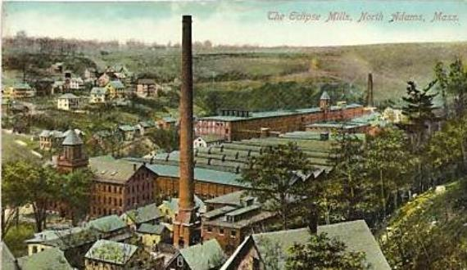
History of the Eclipse Mill: Back long ago in the early 1860’s the Eclipse Mill was ending its stages of being built. It was one of the many factories and mills operating in this city and one of the few textile mills. How did the mill get its name people might wonder? Back in 1853, before the mill was even an idea of being created, a dam was built on the Hoosac River right beside the location of the mill. This dam created an elliptical shape which later on influenced the name of the mill. After its construction, the mill was purchased by its first owner O. Arnold & Co. (Arnold Print Works). The mill was purchased for a total of $300. This purchase would become the fourth mill owned by Arnold Print Works. During this period of being owned by this company it was operated by two major partners in North Adams at the time Gallup and Houghton. The use of the mill at this time was as a cotton mill (later known as a silk mill). A few decades later, in 1911, the Arnold Print Works was bought out by the Hoosac Mill Corporation (Hoosac Cotton Co) due to Arnold & Co going deep into money and business trouble. The new company, in addition to buying the previous Arnold Print Works, also bought the mill across the street known as NoAMA (NoAMA) later became a mill which grew and sold mushrooms until it was shut down in 2000. It later became a storage facility but is now completely shut down after a snow storm that occurred early in 2011.) Between the two mills the company hired 1200 workers within the first year of operating. The operation of the mill was run by a former U.S Senator, William M. Butler. The mill really flourished within the years of the Hoosac Cotton Co and made the company three times stronger, larger, and richer due to all of the products being made and the number of the employers. Hoosac Cotton Co lasted a little over forty years when the mill was then sold to Sprague Electric on May 24, 1957. The mill was generating and creating capacitors and their parts. A little fewer than twenty years later on New Year’s Day of 1973 Sprague Electric Company was shut down and was bought by Hunter Outdoor Products. (Not much information was found about why Sprague was shut down or about the time Hunter Outdoor Products was being operated in the mill.) A few years later the mill was then sold once again to X-TYAL which made military items but later went bankrupt in the 1990’s leaving the mill abandoned and deserted for a few years. The mill stayed abandoned and was falling apart for a couple more years until it was bought yet once again and went through a transformation into what it is now. (Sweeny 134-136) (Manning)
The Workers and Machines of the Eclipse Mill: An abundance of workers walked through the halls of the Eclipse Mill working almost half a day long trying to earn money in order to support their families and put food on the table. A majority of the workers that worked in this mill were French Canadians. Most of these French Canadians were previous farmers who took the train down from Canada to make a better life for their families. In the mills there were usually three types of jobs that a person could have. They could be a:
- Spinner-most of the employers were spinners and would in all probability get paid about fifty cents per hour.
- Mechanics-probably got paid about one dollar per hour.
- Overseers-estimating about two dollars per hour.
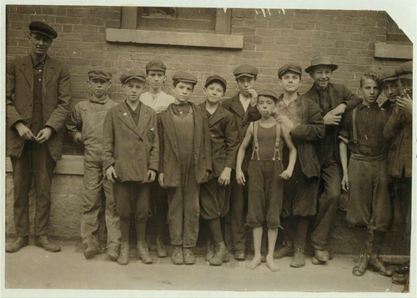
These hard working people would stay on their feet working for about fourteen hours a day except for Sundays which was a day for church and family. Out of all these workers many were children who worked to help support their families. Children as young as the age of four were working hard fourteen hour days instead of expanding their knowledge in school. In 1911 around two million children under the age of sixteen were operating in mills from morning until dusk working in these dangerous mills. Many of the injuries that resulted in these mills were children getting their fingers stuck and cut off trying to operate the machines or trying to clean the machines since their fingers and hands were small enough to do so. In 1916 the first child labor law passed in North Adams but none of the owners of the mills paid much attention to these laws until 1918 when owners started to get in trouble for having children as young as six working in these hazardous places. Injuries occurred daily in the mills resulting in the loss of fingers, hair being ripped out of the head, or arms getting caught in the machines. There weren’t any safety laws during this time and if a worker was injured the company didn’t pay for any medical assistance at all. The shuttle caused most of these accidents. A shuttle was what spun thread in the machines and could spin so fast it could pierce or cut off a ligament. Spinners got stuck very often and would have to be fixed while the machine was still in working mode. Even though almost every square inch of the floor was covered by machines to make an abundance of material there were only a couple of machines. They were the spinning and weaving machines which created the material and cloth that was later sold to other companies to be manufactured into other materials. (Manning) (Brill)
The Present Day of the Eclipse Mill: It is now 2011 and the Eclipse Mill has been completely transformed and is no longer an operating mill. During the early 21st century a man named Eric Rudd, an artist and developer, had the idea to renovate and give the mill some use and value. He transformed this historic mill into lofts for artists to live in and spaces for their studios and shops. The mill is now home to many painters, potters, printmakers, musicians, writers, photographers, dancers, and many more creative and unique artists of today. The mill is also home to a few galleries of North Adams. Well an old mill where disasters happened and many people were injured; is it haunted? It is not truly known if the Eclipse Mill is actually haunted or not but “it sure feels like it,” said Joe Manning in an interview. “If not haunted by ghosts then by memory. The building is still alive with history.” As for the mill across the street, NoAMA or the Sawtooth Mill, it is now under construction due to the snow storm which gave way into caving in the roof. (Manning)
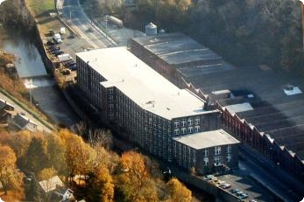
Overall, the city of North Adams has so much detail and life hidden behind its walls that people don’t even know or don’t pay attention to. Stories and life are hidden behind these walls just waiting to be found and heard. People just think that these building are just tall, rundown, and old. They have no idea how wrong they really are. Instead of just driving by an old rundown building or deserted mill, think to yourself, “I wonder what that building was used for way back when?” Think of all of the small details there actually are at every corner you turn. North Adams might be a small quiet city now, but imagine what it was like at the turn of the 20th century. North Adams was booming and profit was high and the city was alive and rich. No one really notices this. One has to become an investigator and dig deep to find the facts and mysteries behind these walls of North Adams. If walls could talk, what would they say? The renovation of the mill has brought North Adams a little part of history back and imagination. Now it is being used for lofts and galleries, but a closer look at all its detail several of the original beat-up floors that the machines rested on with scratches and markings on the floor, the footprints of workers that stood and worked day after day and the original wood beams and brick walls with writings on them. This building might house new homes and residents, but the original craft of the building adds flavor and historic value to the building and adds a historic modern touch to North Adams as well. Hopefully, years and generations from now, the mill will still be what it is adding historic, modern, classy style to the city. Years have passed as citizens watched the Eclipse Mill grow and prosper into a great creation for North Adams and its people. Hopefully newer generations can experience the same as the Eclipse Mill grows even more and stands taller than ever before telling its stories to the people of our town.
